**INFO 6205**

**Program Structures & Algorithms**

**Fall 2020**

**Assignment No.4**

* **Task**
* **Output** (few outputs to prove relationship)
* **Relationship conclusion**
* **Evidence to support relationship** (screen shot and/or graph and/or spreadsheet)
* **Screenshot of Unit test passing**

**Size compression**

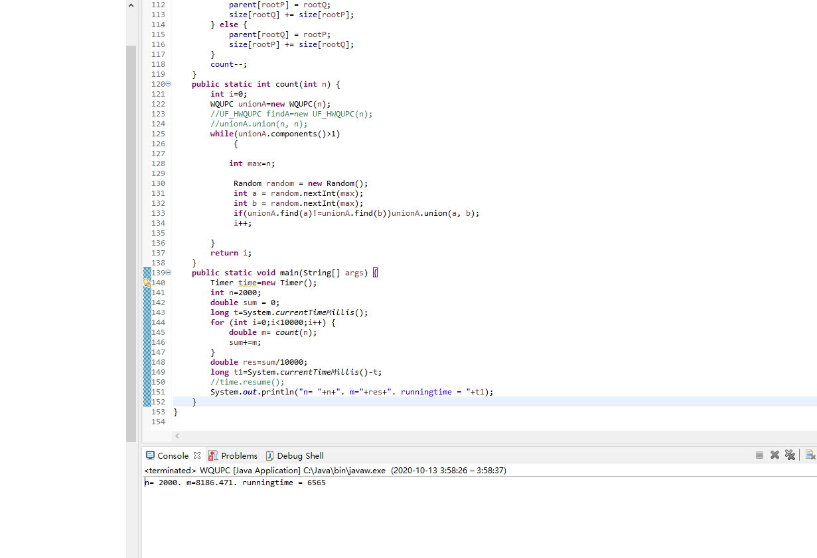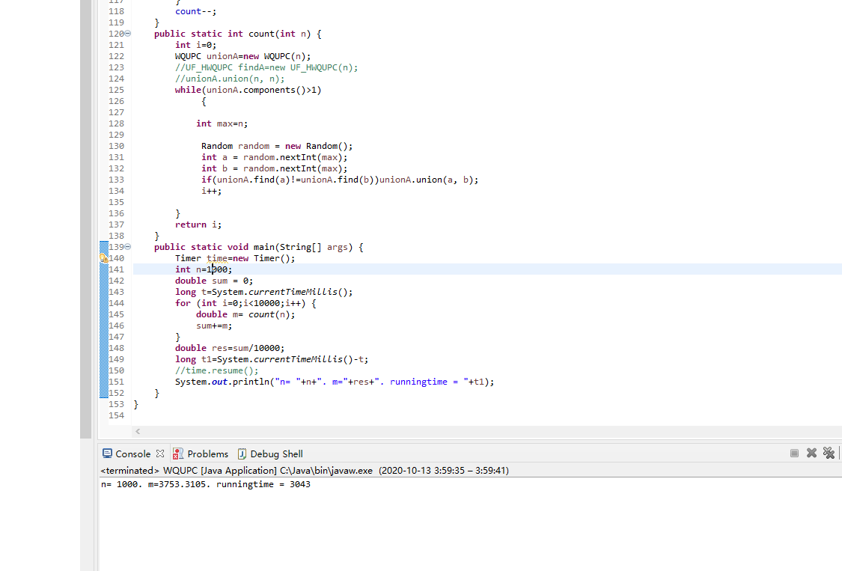 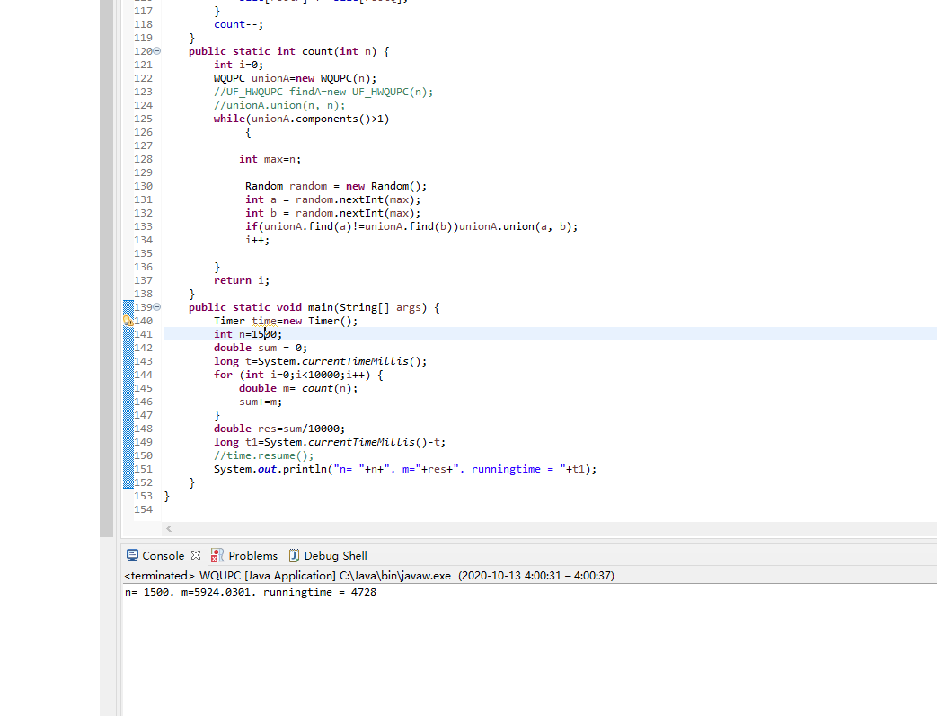 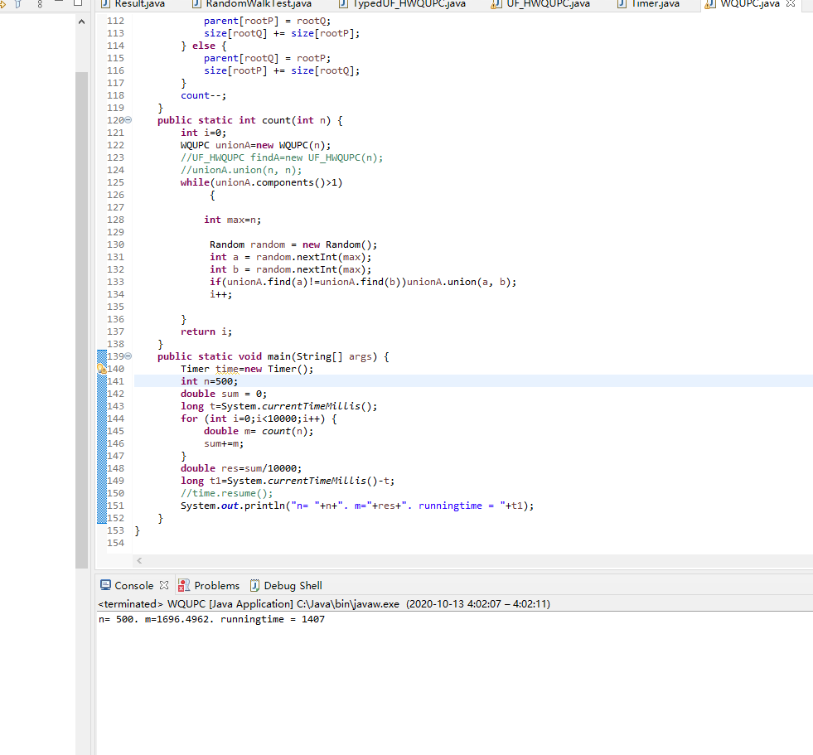 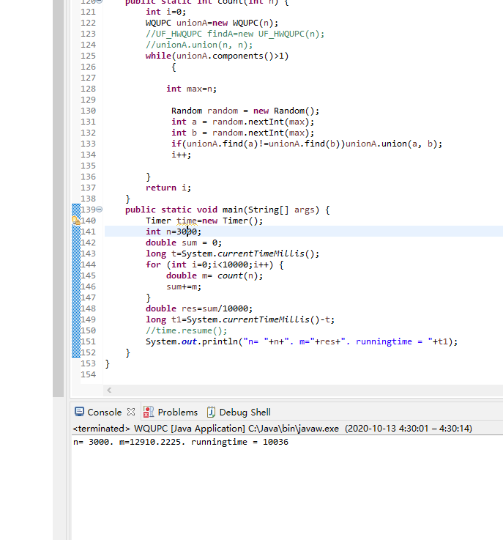

**Height** **compression**

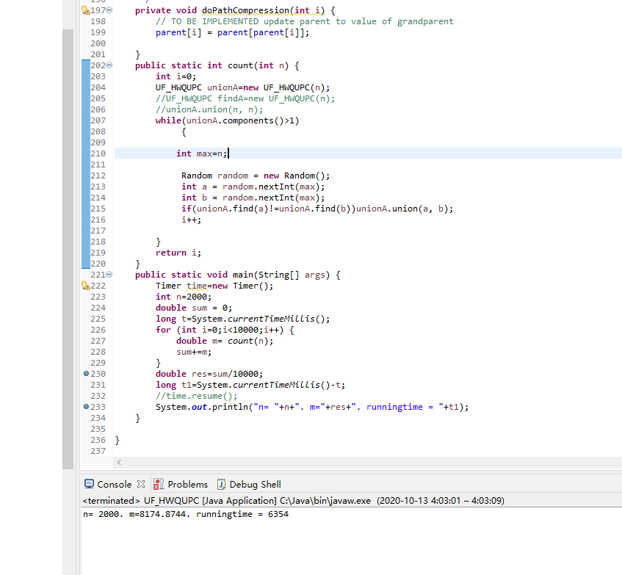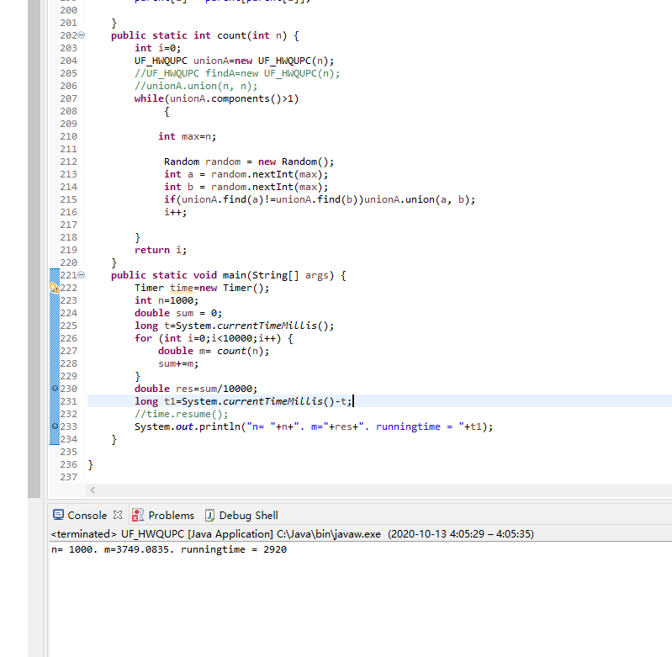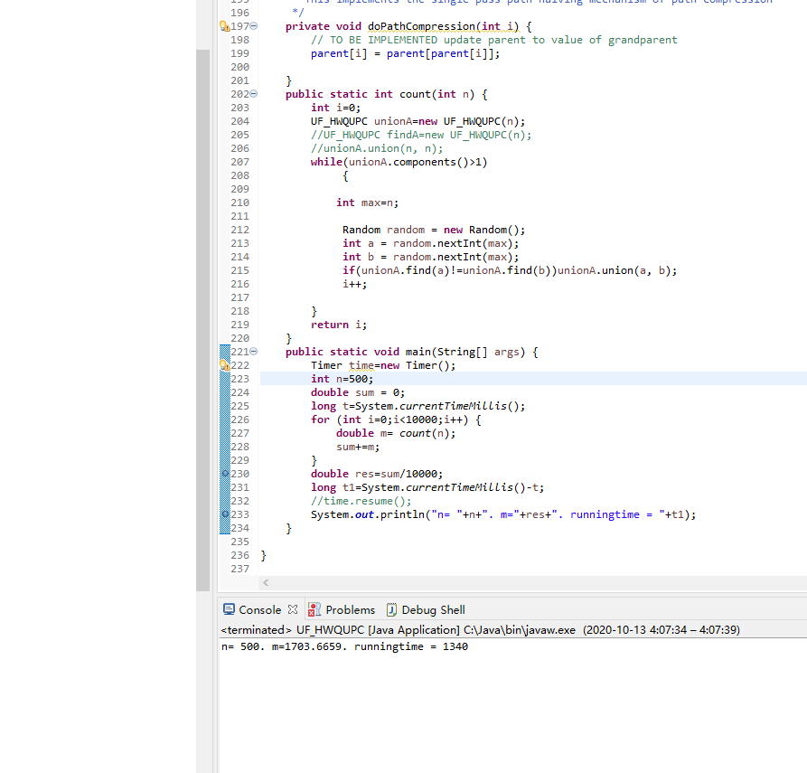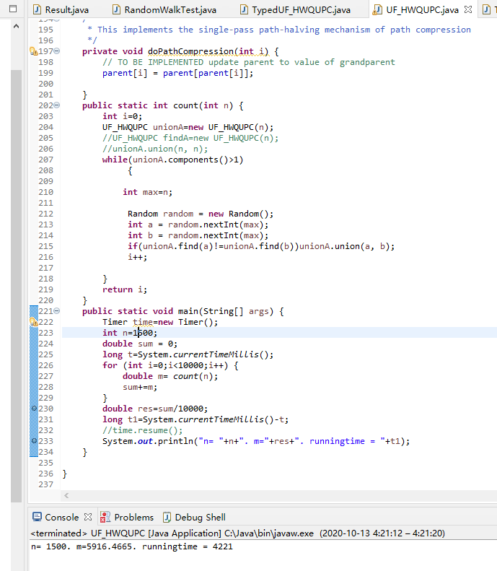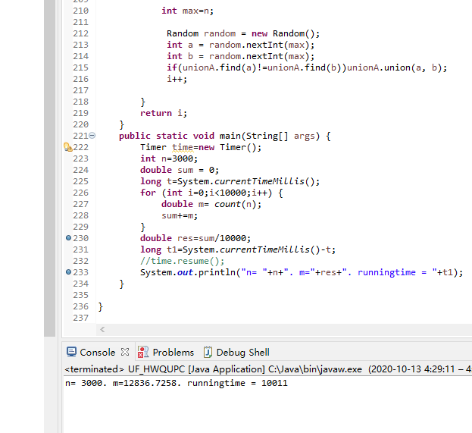

**One path**

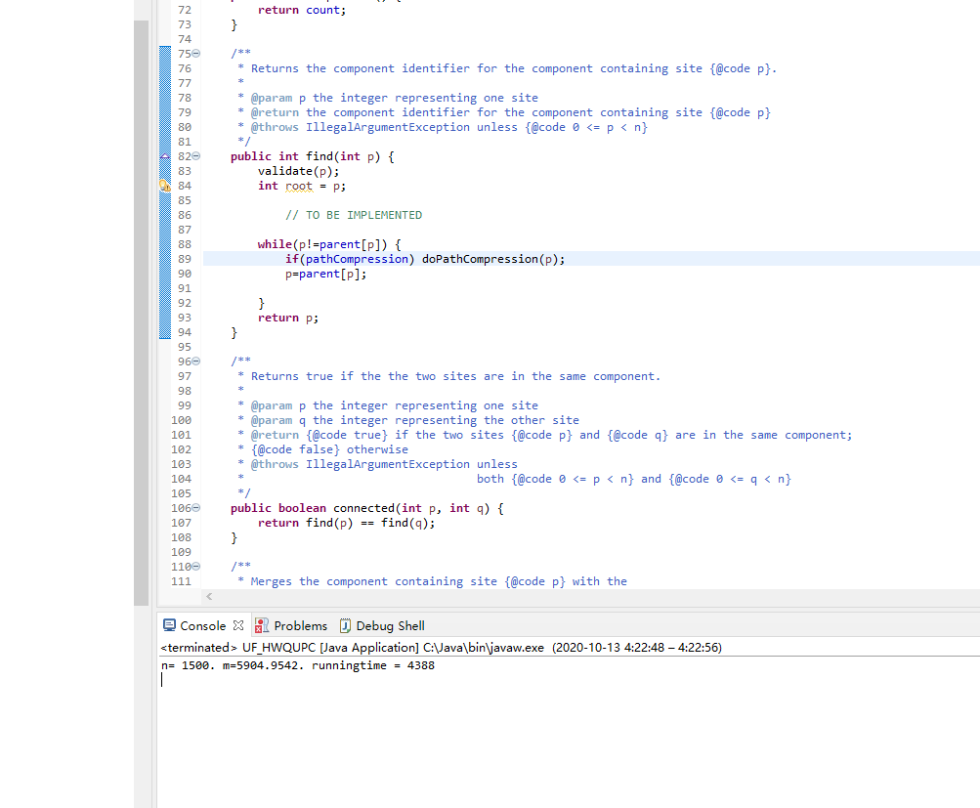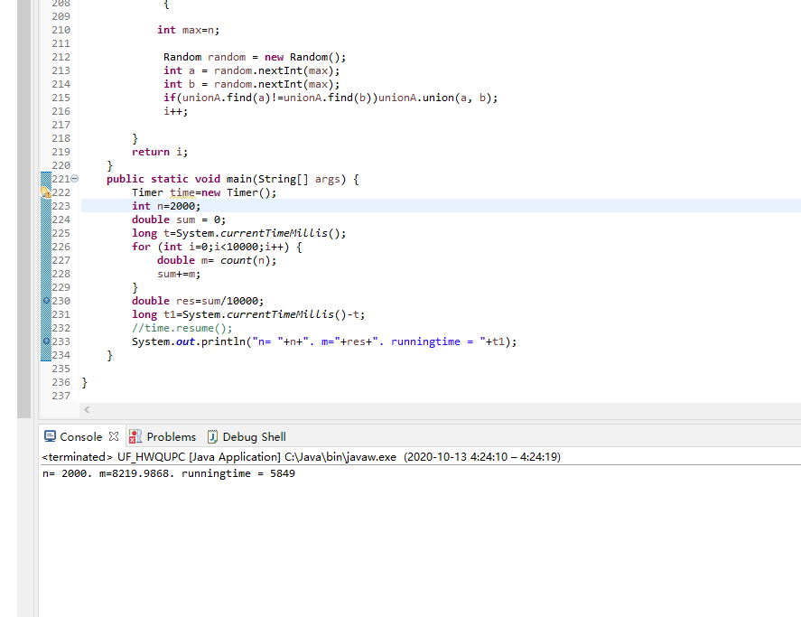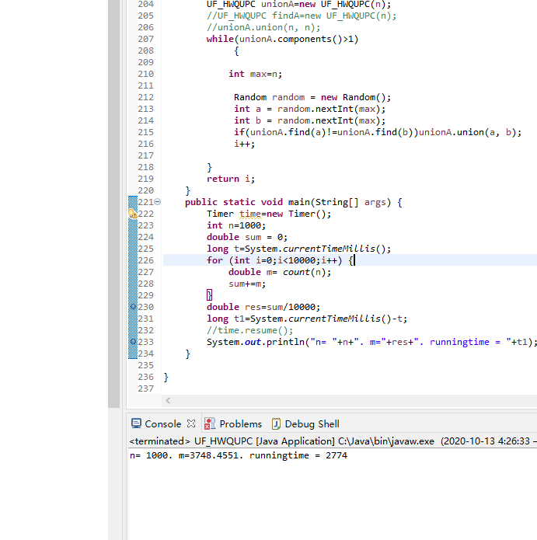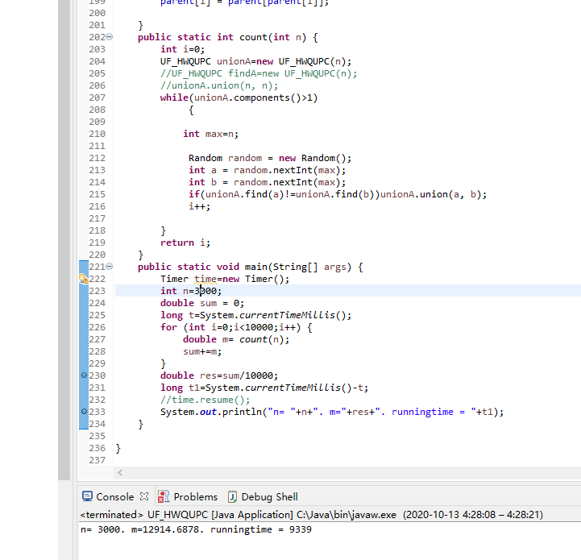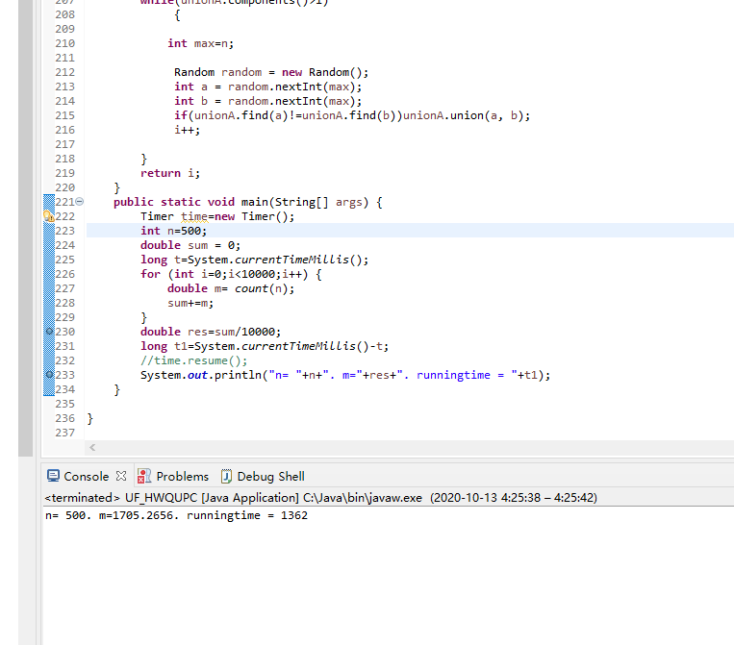

**Two path**

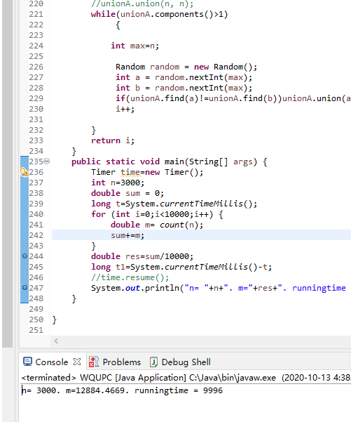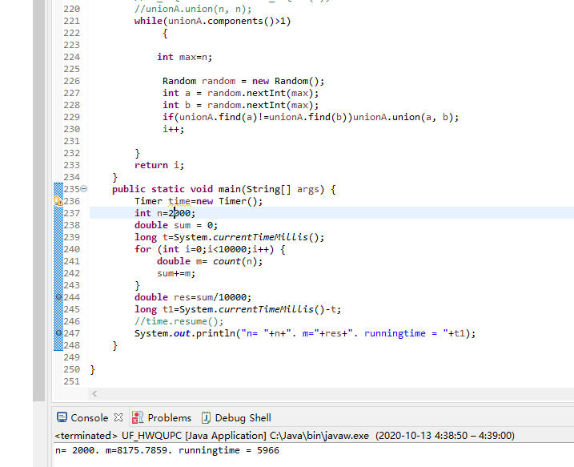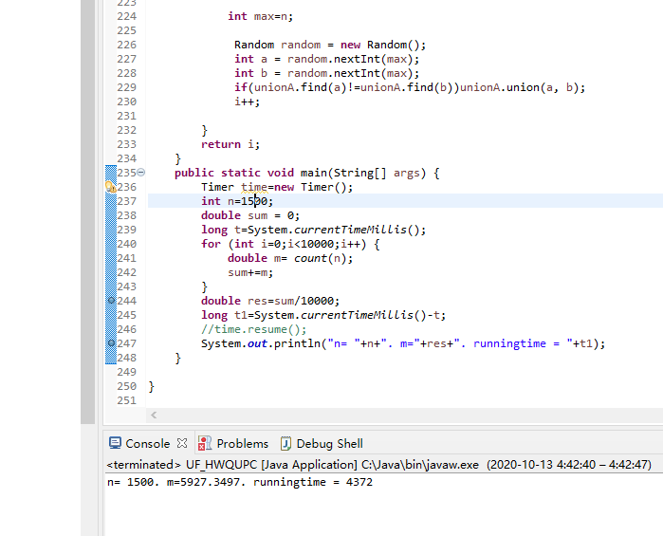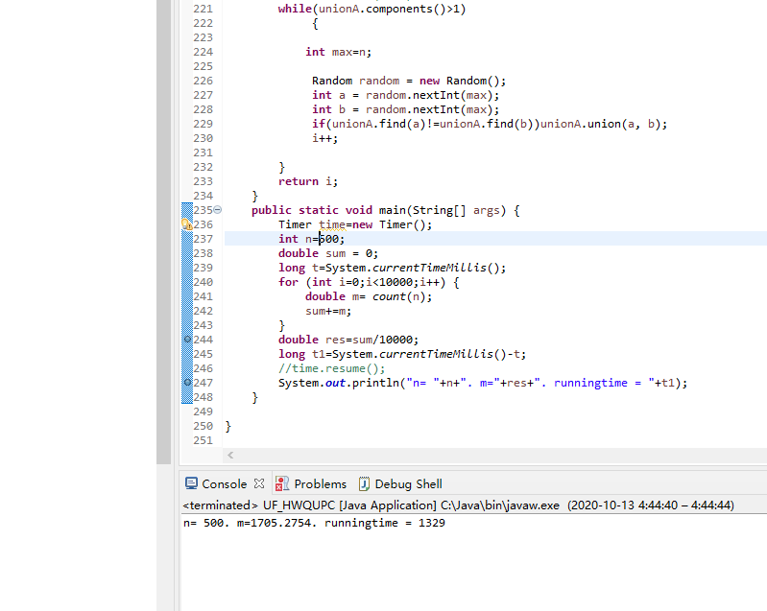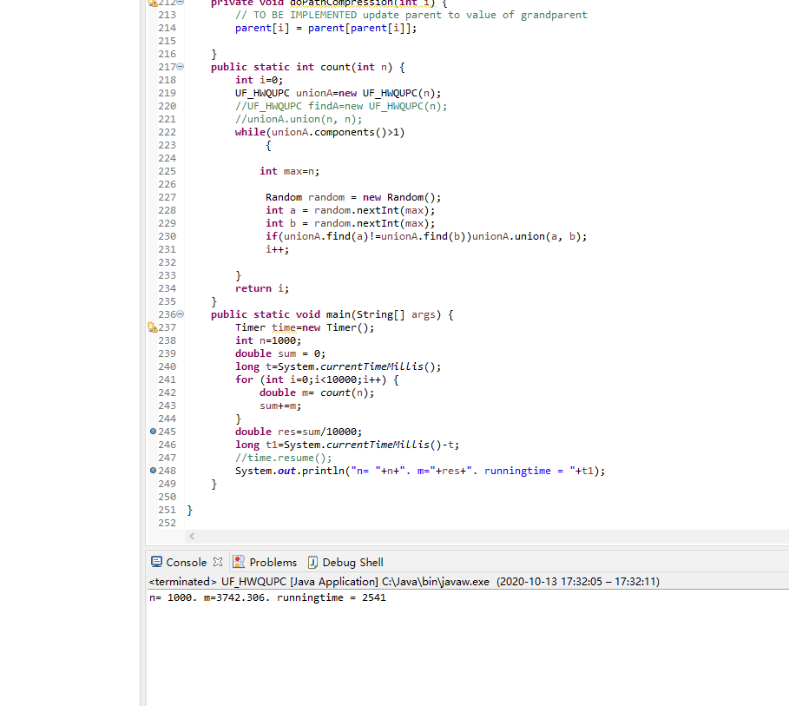

**Then we will collect the data tabulation analysis。**

|  |  |  |
| --- | --- | --- |
| n(size) | m | runningtime(ms) |
| 500 | 1696 | 1407 |
| 1000 | 3753 | 3034 |
| 1500 | 5924 | 4728 |
| 2000 | 8186 | 6565 |
| 3000 | 12910 | 10036 |

|  |  |  |
| --- | --- | --- |
| n(height) | m | runningtime(ms) |
| 500 | 1703 | 1340 |
| 1000 | 3749 | 2920 |
| 1500 | 5916 | 4221 |
| 2000 | 8174 | 6354 |
| 3000 | 12836 | 10011 |

|  |  |  |
| --- | --- | --- |
| n(onepath) | m | runningtime(ms) |
| 500 | 1705 | 1362 |
| 1000 | 3748 | 2774 |
| 1500 | 5904 | 4338 |
| 2000 | 8219 | 5849 |
| 3000 | 12914 | 9339 |

|  |  |  |
| --- | --- | --- |
| n(twopath) | m | runningtime(ms) |
| 500 | 1705 | 1362 |
| 1000 | 3742 | 2541 |
| 1500 | 5927 | 4372 |
| 2000 | 8175 | 5966 |
| 3000 | 12884 | 9996 |

**From the above data, I observed that the two running times without path- COMPRESSION were approximately the same. The two times in which path Compression was used were essentially the same and slightly faster.**

**When we do the find operation, we not only find the root node we need to look for, but also compress the tree, which is the meaning of path compression. With path compression, the next time we perform find with as few layers as possible, the efficiency will be greatly improved.**